EXP NO 5:

Create a simple cloud software application for online super market using any Cloud Service Provider to demonstrate SaaS with the template of customer name, address, phone, email, items, quantity etc. with the item classification form.

DATE:

AIM:

To Create a simple cloud software application for online super market system using any Cloud Service Provider to demonstrate SaaS.

PROCEDURE:

Step1: Go to zoho.com.

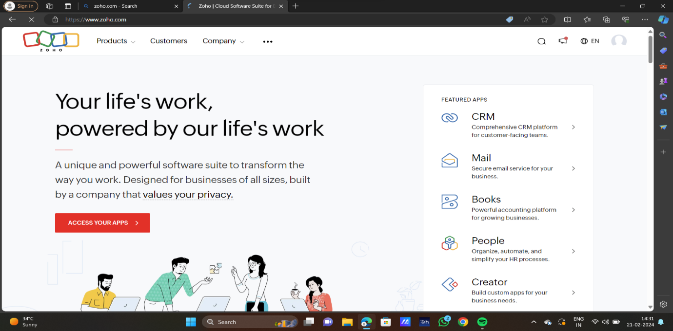

STEP2:LOG INTO THE ZOHO.COM

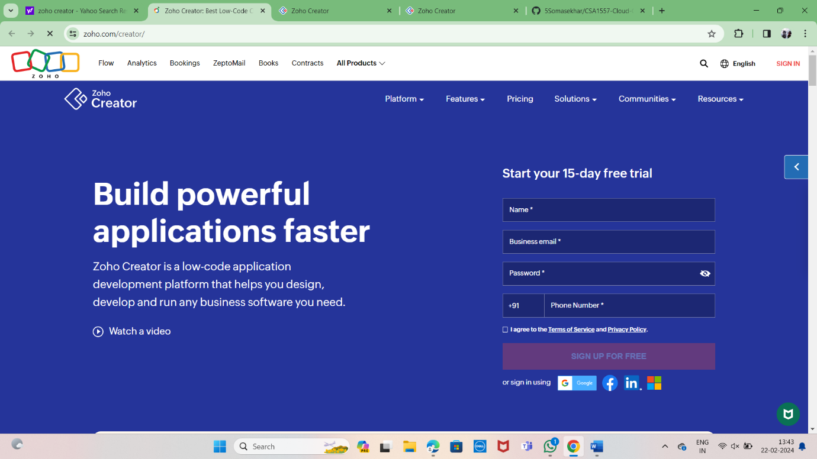

STEP3: SELECT ONE APPLICATION

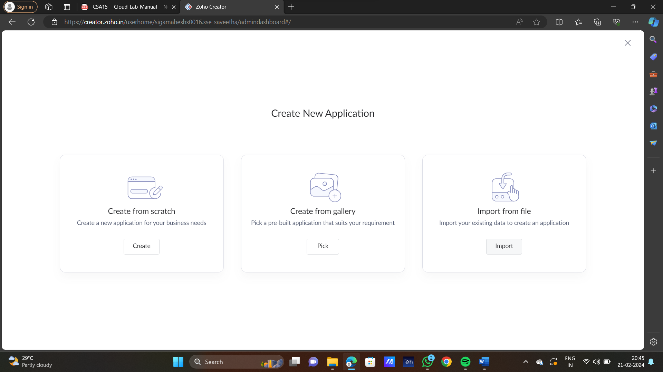

STEP4: ENTER APPLICATION NAME

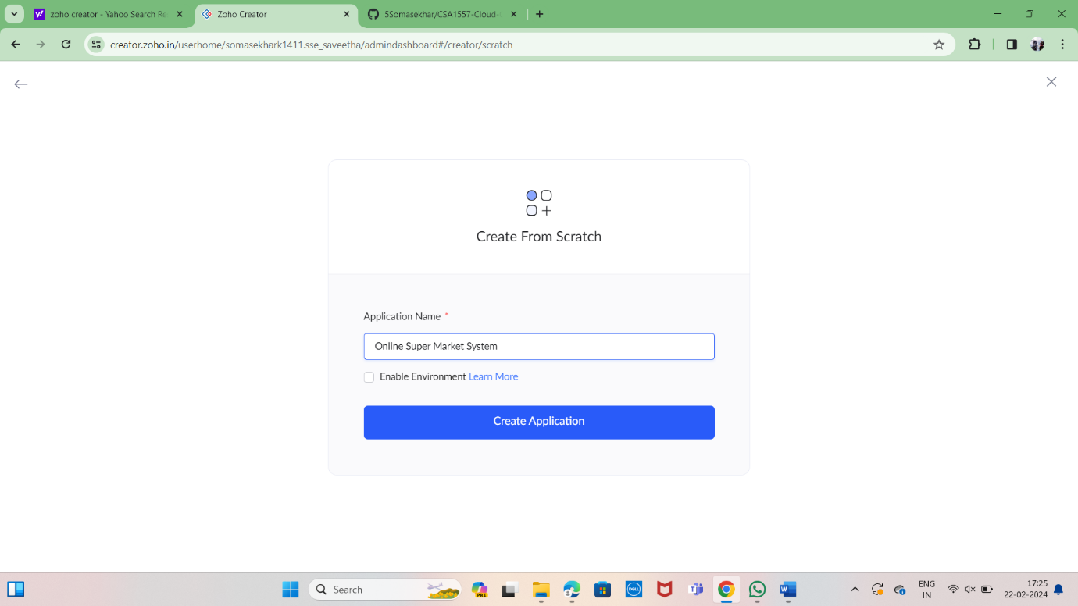

STEP5: CREATED NEW APPLICATION

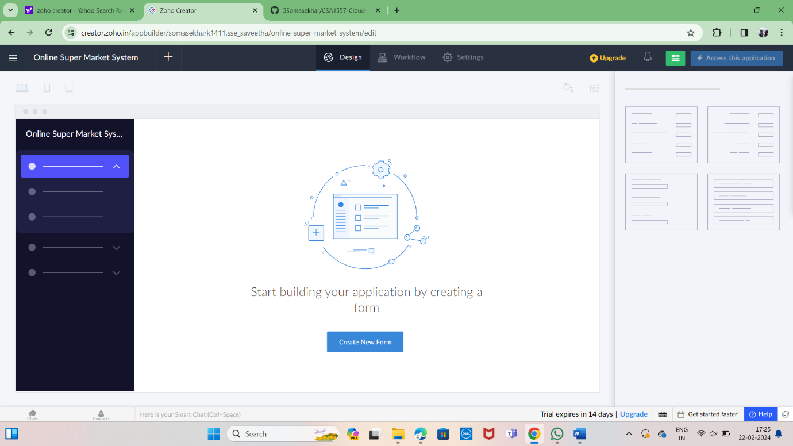

STEP 6: SELECT ONE FORM

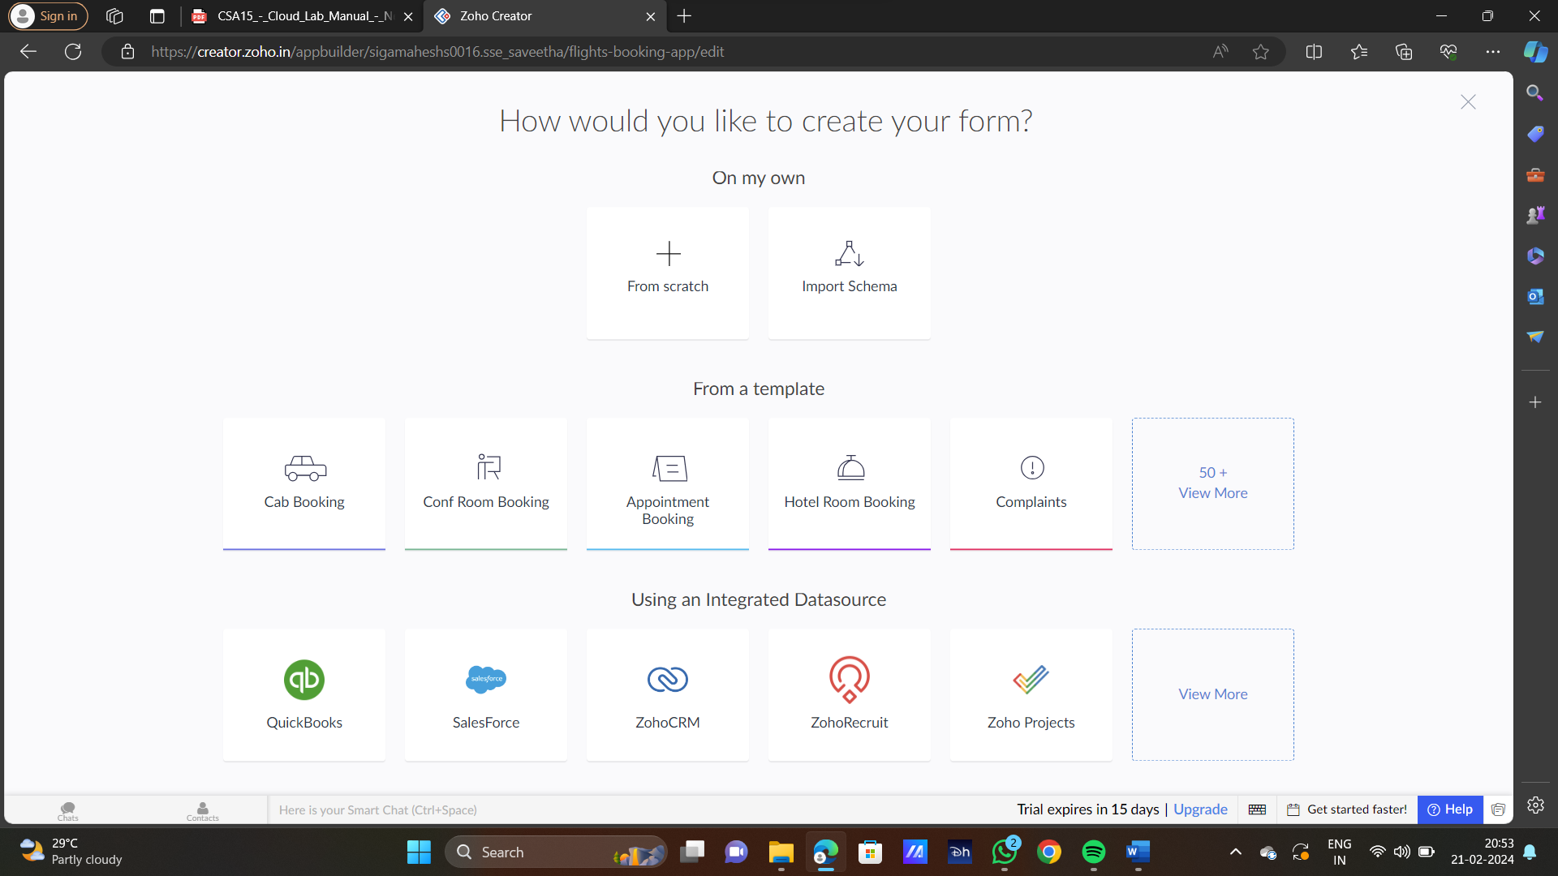

STEP 7: THE SOFTWARE HASE BEEN CREATED

